MGMS –Proposal Evaluation

Functional Specification Document

Ver. 1.4

Version History
Date | Description
21-Nov-2010 | First Draft

Table of Contents

Version History 2
1 Introduction 4
1.1 Purpose 4
1.2 Scope 4
1.3 Assumptions 4
1.4 Constraints 4
2 Sub Menu - Call for Proposal 4
3 Business Rules 5
4 Error Messages 6

Introduction

Purpose

This document provides the requirements and functional specifications for the Proposal evaluation section of the Multisite Grant Management System project.
This is not a project plan or a design document. It is a guide for system architecture and development, not for phasing, timelines or deliverables.
Finally, this is a ‘living document’ and the specification will change, continuously, as the project proceeds. More details will be added and the existing information edited as the requirements, scenarios and use cases evolve in the course of the project.

Scope

Assumptions

Constraints

Proposal Evaluation

The Notification List page lists out all the projects for which proposals have been requested by the user’s institution (grantor). From here, the grantor can do the following, for each project:

- View the application form
- Upload attachments
- Publish notification
- View proposals already submitted by interested institutions
- Edit notification

When the notification is published, all institutions in the system will get the notification in their Proposal Management section of the GMS.

Screen & Control Description

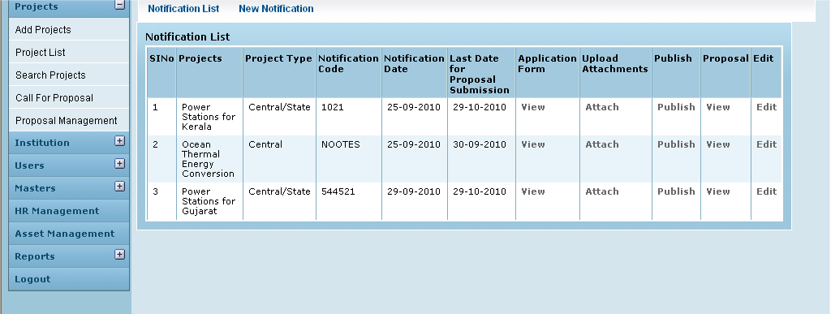

Field /Label | Input-Control | Data Type | Remarks
Notification List | Link
New Notification | Link | To the editor where new notification can be created saved , and attachments uploaded
Notification List
SlNo | Auto increment populated
Projects | Auto populated | String | projects>name
Project Type | Auto populated | String | project_type>type
Notification Code | Auto populated | String | notification>notification_code
Notification Date | Auto populated | datetime | notification>notification_date
Last Date for Proposal Submission | Auto populated | datetime | notification> proposal_submission_last_date
Application Form | “View” - link
Upload Attachments | “Attach” – link
Publish | “Publish” – link
Proposal | “View” - link
Edit | “Edit” - link

Clicking on View in Proposal column, the following screen opens up

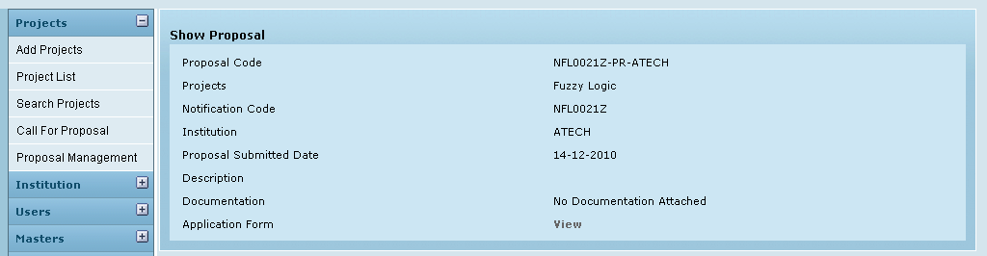

Clicking On VView

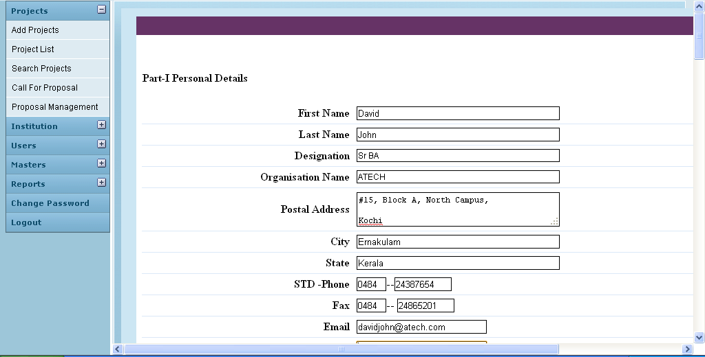

Click Review under Eligibility Check

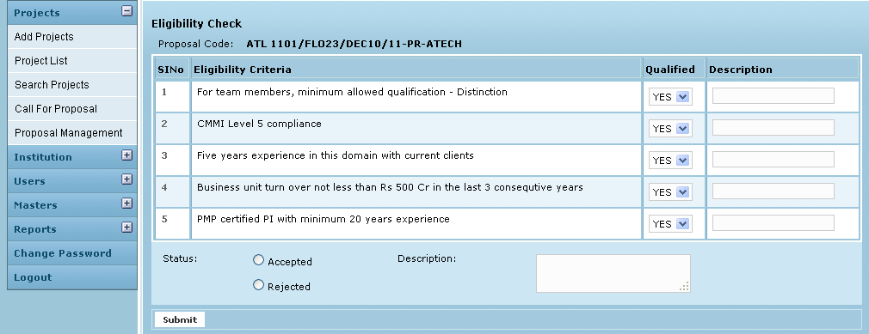

On clicking Submit

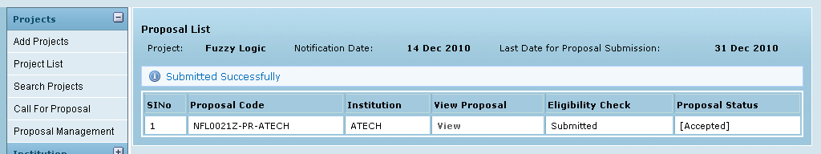

Business Rules

Error Messages

Sl No | Status Message
1 | Submitted Successfully
2 | Updated Successfully
3 | Deleted Successfully
4 | The Requested Record Not Found
5 | The Record can't be deleted, Already in use
6 | The Record Already Exists
7
8

